Common points to know before start
V$SQL_PLAN: Default view to show the execution plan for all compiled/executed queries. SYS is owner of this view.
EXPLAIN PLAN Command: Command to generate explain plan for any given query without executing it.

PLAN_TABLE: Default table to store explained plan. This is a global temporary table and default plan table but user can create his/her own plan table and refer that. We will discuss this later.
DBMS_XPLAN: Oracle built-in package to format the generated explain plan. This package defined several functions which can be used to display execution plans but we are going to cover below two functions.
- DISPLAY
- DISPLAY_CURSOR

Getting start with Explain Plan

How to generate Explain Plan: Explain plan can be generated using EXPLAIN PLAN command as shown below. This command will generate the explain plan without executing the query.

EXPLAIN PLAN SET STATEMENT_ID=<<Statm_id>> INTO <<Plan Table>> FOR <<SQL Statement>>
Statement id and Plan table are optional.

Example 1: EXPLAIN PLAN FOR SELECT * FROM emp e, dept d WHERE e.deptno = d.deptno;
- You can define statement id for each plan, which will help you to identify the specific plan among other plans.
Example 2: EXPLAIN PLAN SET STATEMENT_ID=’EMP_DEPT’ FOR SELECT * FROM emp e, dept d WHERE e.deptno = d.deptno;
- You can create your own plan table and generate explain plan in your plan table.
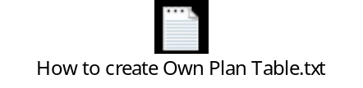Use this script to create your own plan table.
After you created your own plan table now you can generate explain plan in your table by using below command.
EXPLAIN PLAN INTO my_plan_tab FOR SELECT * FROM emp e, dept d WHERE e.deptno = d.deptno;
How to display Explain Plan: You can use display and display_cursor function available in built-in package dbms_xplan to display execution plan.

DISPLAY: Used to display the execution plan produced by an EXPLAIN PLAN command. You can either display the most recent explained statement, or the statement for a specific statement id. This function is having three option parameters.

Parameter’s | Description of parameter’s | Default value for Parameter
Table Name | - Name of the plan table. Helpful when user has defined his/her owner plan table and want to extract execution plan from their plan table. | - PLAN_TABLE
Statement Id | - Statement Id of the plan which need to display.  - Helpful when statement Id is mentioned during plan generation.  - If this parameter is pass as NULL the most recent generated plan will be return/display by this function. | - NULL
Format | - Control the level of details need to display.  - Possible values BASIC,TYPICAL,SERIAL and ALL | - TYPICAL

Examples:
- EXPLAIN PLAN FOR SELECT * FROM emp e, dept d WHERE e.deptno = d.deptno;

SELECT * FROM TABLE (dbms_xplan.display ());
OR
SELECT * FROM TABLE (dbms_xplan.display (NULL, NULL, NULL));
OR
SELECT * FROM TABLE (dbms_xplan.display ('PLAN_TABLE', NULL, NULL));
With this call oracle will display the most recent generated explain plan from PLAN_TABLE and details level will be TYPICAL.
- EXPLAIN PLAN SET STATEMENT_ID='MY_PLAN0001' FOR SELECT * FROM emp e, dept d WHERE e.deptno = d.deptno;

SELECT * FROM TABLE (dbms_xplan.display (NULL, ’MY_PLAN0001’, NULL));
OR
SELECT * FROM TABLE (dbms_xplan.display (NULL, ’MY_PLAN0001’));
With this call oracle will display the execution plan whose id is ’MY_PLAN0001’ in PLAN_TABLE and details level will be TYPICAL.
- EXPLAIN PLAN FOR SELECT * FROM emp e, dept d WHERE e.deptno = d.deptno;

SELECT * FROM TABLE (dbms_xplan.display (NULL, NULL,’BASIC’));
OR
SELECT * FROM TABLE (dbms_xplan.display (NULL, NULL,’ALL’));
With this call oracle will display the most recent generated explain plan from PLAN_TABLE and details level will be varying in Basic and ALL format.
- EXPLAIN PLAN INTO my_plan_tab FOR SELECT * FROM emp e, dept d WHERE e.deptno = d.deptno;

SELECT * FROM TABLE (dbms_xplan.display ('MY_PLAN_TAB', NULL, NULL));
OR
SELECT * FROM TABLE (dbms_xplan.display ('MY_PLAN_TAB'));
With this call oracle will display the most recent generated explain plan from MY_PLAN_TAB and details level will be TYPICAL.

DISPLAY_CURSOR: Displays the execution plans for one or several cursors in the shared SQL area, depending on filter criteria. It can display the plan for the last executed statement, the current (if session is active) or last executed statement (if session is inactive) of a specific session, or all cursors matching an arbitrary criteria defined via SQL

Specific cursors are identified by SQL_ID and optionally a SQL_CHILD_NUMBER.

The DEFAULT without any parameters shows the last executed statement of the session.

NOTE: To use the DISPLAY_CURSOR functionality, the calling user must have SELECT privilege on V$SQL_PLAN_STATISTICS_ALL, V$SQL, and V$SQL_PLAN. By default, only the select_catalog role has the SELECT privilege on these views.

Parameter’s | Description of parameter’s | Default value for Parameter
SQL Id | Whenever we execute a statement, oracle will generate the SQL_ID for that statement. Pass that SQL_ID in function to the plan for that statement. You can get SQL_ID from v$sql.sql_id, v$session.sql_id and v$session.prev_sql_id | - NULL
Cursor Child Number | Pass the child number of statement. You can get child number from v$sql.child_number, v$session.child_number and v$session.prev_child_number. | - 0
Format | - Control the level of details need to display.  - Possible values BASIC, TYPICAL, SERIAL and ALL. | - TYPICAL
How to read Explain Plan: The EXPLAIN PLAN statement displays execution plans chosen by the Oracle optimizer for SELECT, UPDATE, INSERT, and DELETE statements. Statement's execution plan is the sequence of operations Oracle performs to execute the statement. The components of execution plans include:
- An ordering of the tables referenced by the statement
- An access method for each table mentioned in the statement
- A join method for tables affected by join operations in the statement
EXPLAIN PLAN output shows how oracle executes SQL statements. In order to determine if you are looking at a good execution plan or not, you need to understand how the optimizer determined the plan in the first place. You should also be able to look at the execution plan and assess if the optimizer has made any mistake in its estimations or calculations, leading to a suboptimal plan. The components to assess are:

- Cardinality– Estimate of the number of rows coming out of each of the operations.
- Access method – The way in which the data is being accessed, via either a table scan or index access.
- Join method – The method (e.g., hash, sort-merge, etc.) used to join tables with each other.
- Join type – The type of join (e.g., outer, anti, semi, etc.).
- Join order – The order in which the tables are joined to each other.
- Partition pruning – Are only the necessary partitions being accessed to answer the query?
- Parallel Execution – In case of parallel execution, is each operation in the plan being conducted in parallel? Is the right data redistribution method being used?

NOTE:
- Oracle will always generate the explain plan either based on available statistics or dynamic sampling (Statistics generated at run time). For better plan always maintain latest statistic of objects in your database.
- Plan generated through explain plan command may not be the same plan which oracle will use at the time of query execution. Generated plan may vary with actual used plan.

Access methods: Access method or access path shows how data will be access from each tables, views and indexes.

The access method is always shown in the operation field of the explain plan.
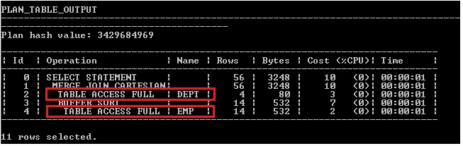

Oracle supports 9 types of access methods.

- Full table scan.
- Table access by ROWID.
- Index unique scan.
- Index range scan.
- Index skip scan.
- Full index scan.
- Fast full index scan.
- Index Join.
- Bitmap index.
Full Table Scan: Reading all the rows from table. Reason could be following.
- Table is not having any appropriate indexes.
- Need to access most of the block of the table.
- Table is small.
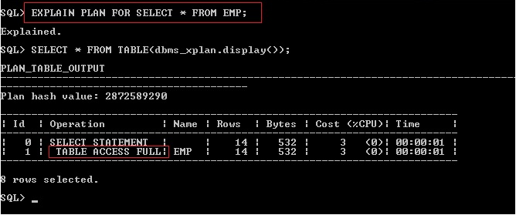
In above example, statement is not having any where clause and selecting all the columns of emp table, it’s causing oracle optimizer to access all block of the emp table through FULL TABLE SCAN.

Table access by ROWID/ ROWID Scan: Reading the rows from table based on ROWID. Reason could be following.
- Where clause condition specifies using ROWID.
- Data are access through Index Scan.
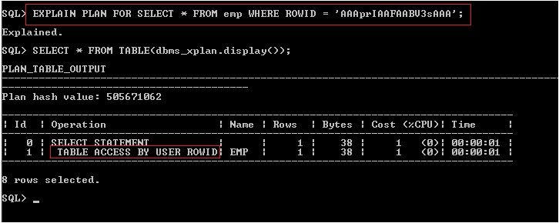
In above example, data retrieve from table based on ROWID which is causing oracle optimizer to access data from emp table through ROWID SCAN.

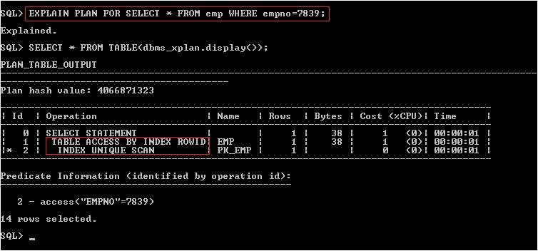
In above example, data retrieve from table based on Index scan which is causing oracle optimizer to use index ROWID to access the record from emp table through ROWID SCAN.

NOTE: empno column is primary key column in EMP table, in this case oracle automatic created unique index on this column. In above query we are referring to this column with equality operator which is causing optimizer to access the data of EMP table through UNIQUE INDEX SCAN. And in case if data access through any index scan method, table will always be access by ROWID.

Unique Index Scan: Reading only single row from table. Reason could be following.
- Trying to accessing a row/record based on column which is part of unique index.
Unique index could be created manually or automatically by oracle in case of creating unique or primary key constraints.
- Filter/Where clause must have only equality operator.
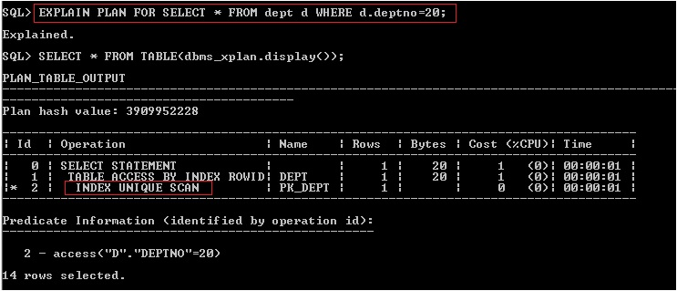
In above example, deptno column is primary key column in DEPT table, in this case oracle automatic created unique index on this column. We are referring to this column in query with equality operator which is causing optimizer to access the data of DEPT table through UNIQUE INDEX SCAN.
Index Range Scan: Reason could be following.
- Statement has non-equality or range operator/predicates on unique index column. i.e <,>, >=, <= and Between etc.
- Statement is accessing the rows based on non-unique index.
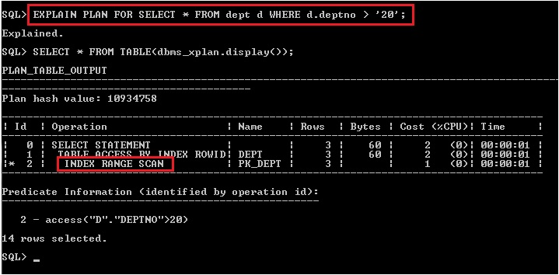

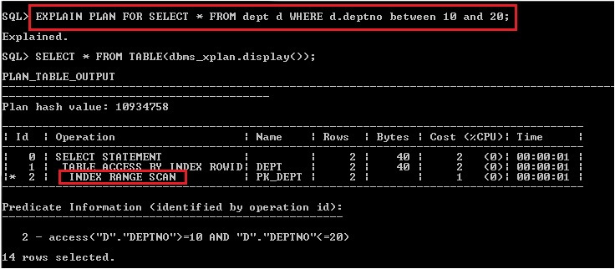
In above both examples, statement is having non-equality predicate on unique index which is causing optimizer to access the rows through INDEX RANGE SCAN.

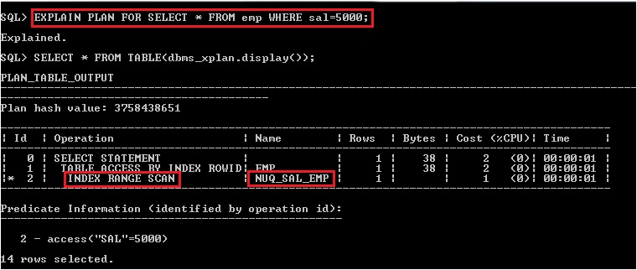
In above example, statement is having equality predicate on non-unique index which is causing optimizer to access the rows through INDEX RANGE SCAN.

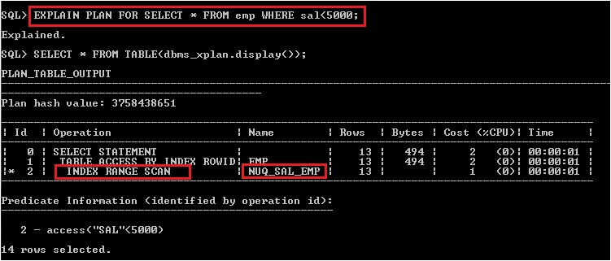
In above example, statement is having non-equality predicate on non-unique index which is causing optimizer to access the rows through INDEX RANGE SCAN.

NOTE: Before executing these examples create an index on non-unique column. To showcase this case I have created index on sal column using below command.

CREATE INDEX nuq_sal_emp ON emp(sal);
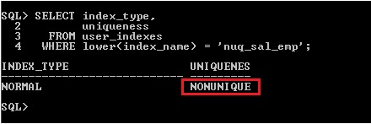
Index Skip Scan: Reason could be following.
- If all the other columns in the index are referenced in the statement except the first/leading column. i.e my composite key is made up of (col1,col2,col3) and in your statement you are using col2 and col3 only or col3 only.
- It is advantageous if leading column is more redundant values and subsequent columns are having less redundant values.
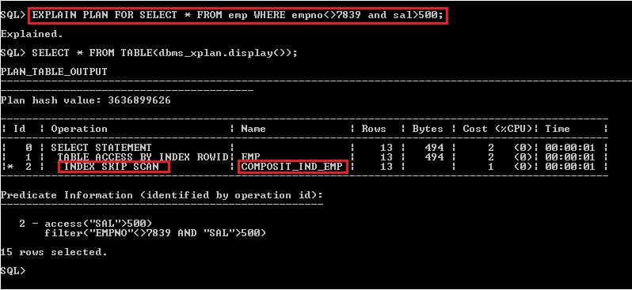
In above example, statement is referring to all others column of a composite index except the leading/first column which is causing optimizer to access the rows through INDEX SKIP SCAN.

NOTE: In order to showcase this case, I have created a composite index on deptno, empno and sal column of EMP table as shown below.

CREATE INDEX composit_ind_emp ON emp(deptno,empno,sal);

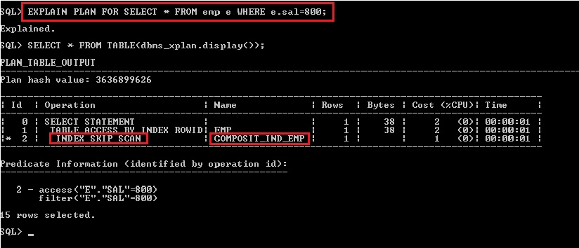
In above example, statement is referring to last column of composite index except both the leading/first column which is causing optimizer to access the rows through INDEX SKIP SCAN.

Index Full Scan: It is used when all of the columns necessary to satisfy the statement are in the index and it is cheaper than scanning the table. Reason could be following.
- An ORDER BY clause has all the index columns and in same order as it defined in index.
NOTE: Order of columns need to be same as defined in index and no other columns should present in ORDER BY clause except columns present in index.
- A GROUP BY clause is present in the statement and columns presents in GROUP BY are presents in index.
  - In case if index in defined on single column and GROUP BY clause in statement is also having that column alone then optimizer will access data using INDEX FULL SCAN.
NOTE: If GROUP BY clause containing other columns too which is/are not present in index then optimizer will not access data using INDEX FULL SCAN.
  - In case of composite index if GROUP BY clause is having all the columns present in composite index then optimizer will access data using INDEX FULL SCAN.
NOTE: If GROUP BY clause containing other columns too which is/are not present in index then optimizer will not access data using INDEX FULL SCAN.
Order of the columns in GROUP BY clause may vary no need to be the same order as defined in composite index.
- Columns present in the statement are present in the index and in same order as defined in index.
NOTE: If statement containing other columns which are not present in index then optimizer will not access data using INDEX FULL SCAN.

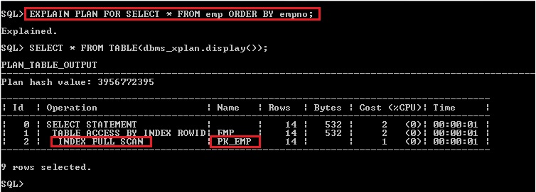
In above example, statement is having ORDER BY clause containing only empno column. This causing optimizer to access the data based on PK_EMP index through INDEX FULL SCAN.
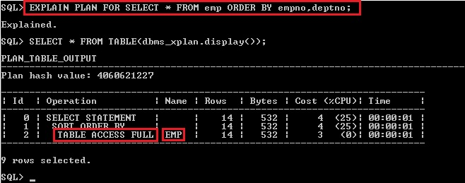
In above example, statement is having ORDER BY clause containing empno and deptno column. PK_EMP index in defined for empno alone but in ORDER BY clause deptno column is also present which causing optimizer to not access the data based on PK_EMP index.

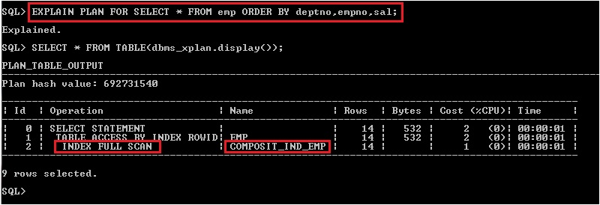
In above example, statement is having ORDER BY clause containing deptno, empno and sal column. COMPOSIT_IND_EMP composite index is defined for all three columns and in same order, which is causing optimizer to access the data based on COMPOSIT_IND_EMP index through INDEX FULL SCAN.

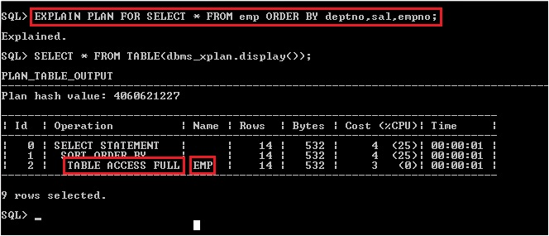
In above example, statement is having ORDER BY clause containing deptno, sal and empno column. COMPOSIT_IND_EMP composite index is defined for all three columns but in different order i.e deptno, empno and sal , which is causing optimizer to not access the data based on COMPOSIT_IND_EMP index.

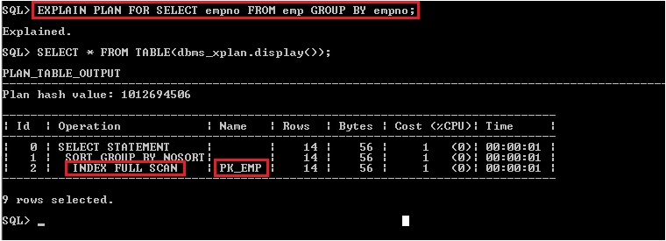
In above example, statement is having GROUP BY clause containing empno column. PK_EMP index in defined for empno, which is causing optimizer to access the data based on PK_EMP index through INDEX FULL SCAN.

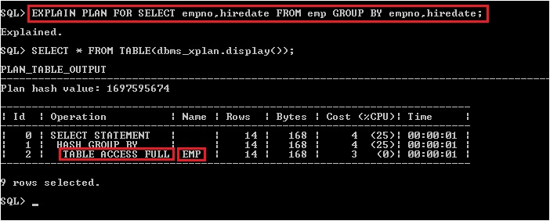
In above example, statement is having GROUP BY clause containing empno and hiredate column. PK_EMP index in defined for empno alone but in GROUP BY clause hiredate is also present, which is causing optimizer to not access the data based on PK_EMP index.

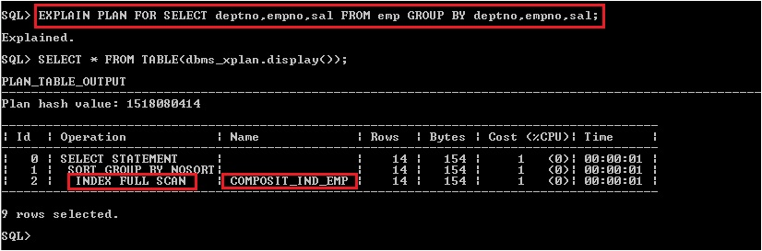
In above example, statement is having GROUP BY clause containing deptno, empno and sal column. COMPOSIT_IND_EMP composite index is defined for all three columns, which is causing optimizer to access the data based on COMPOSIT_IND_EMP index through INDEX FULL SCAN.

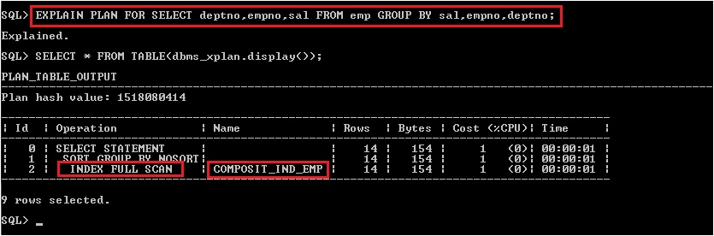
Order of column will not make any difference.
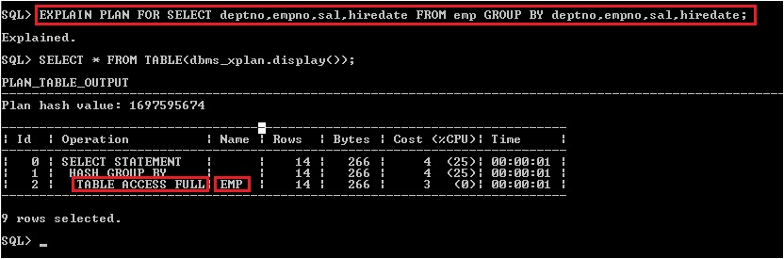
In above example, statement is having GROUP BY clause containing deptno, empno, sal and hiredate columns. COMPOSIT_IND_EMP composite index is defined for deptno, empno and sal columns only but hiredate is also present in GROUP BY clause, which is causing optimizer to not access the data based on COMPOSIT_IND_EMP index.

  - GROUP BY deptno
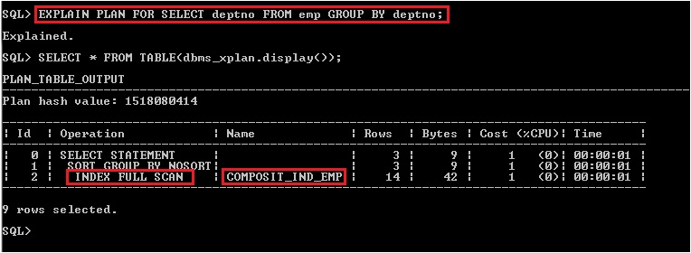

  - GROUP BY sal
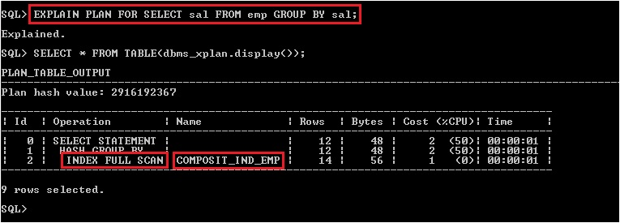

  - GROUP BY deptno,sal
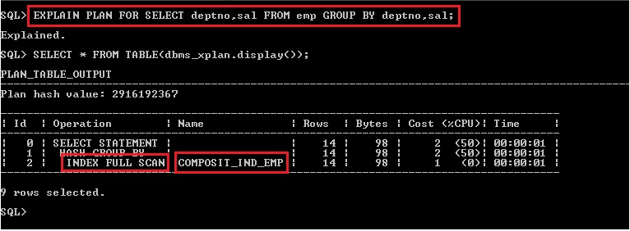
  - GROUP BY sal,empno
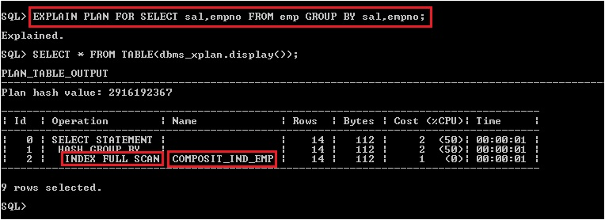
In above all 4 examples, statement is having GROUP BY clause and containing one or more columns which are part of composite column, which is causing optimizer to access the data based on COMPOSIT_IND_EMP index through INDEX FULL SCAN.

NOTE: Order of column makes no difference in case of composite key index for INDEX FULL SCAN.

Fast full index scan: This is an alternative to a full table scan when the index contains all the columns that are needed for the query, and at least one column in the index key has the NOT NULL constraint. It cannot be used to eliminate a sort operation, because the data access does not follow the index key. It will also read all of the blocks in the index using multi block reads, unlike a full index scan.

Index join: This is a join of several indexes on the same table that collectively contain all of the columns that are referenced in the query from that table. If an index join is used, then no table access is needed, because all the relevant column values can be retrieved from the joined indexes. An index join cannot be used to eliminate a sort operation.

Bitmap Index: A bitmap index uses a set of bits for each key values and a mapping function that converts each bit position to a rowid. Oracle can efficiently merge bitmap indexes that correspond to several predicates in a WHERE clause, using Boolean operations to resolve AND and OR conditions.
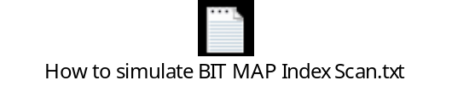Use this script to modify emp table and create bitmap index on emp table.

Operation performed on column which are present in bitmap index will cause optimizer to access the data through bitmap index and can use below access methods.

- Bitmap index single value scan
- Bitmap index range scan
- Bitmap index skip scan
- Bitmap index full scan

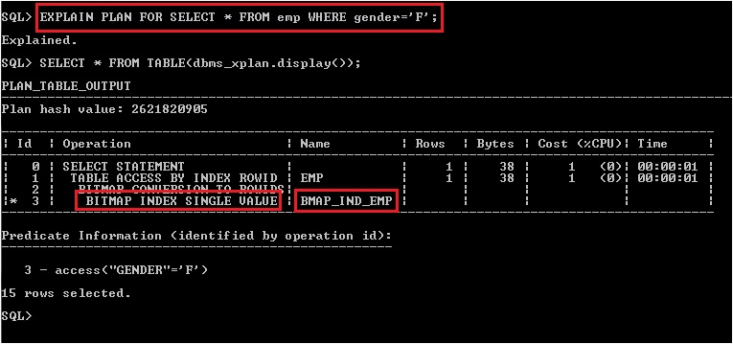

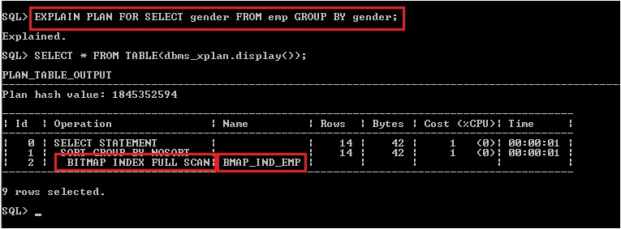

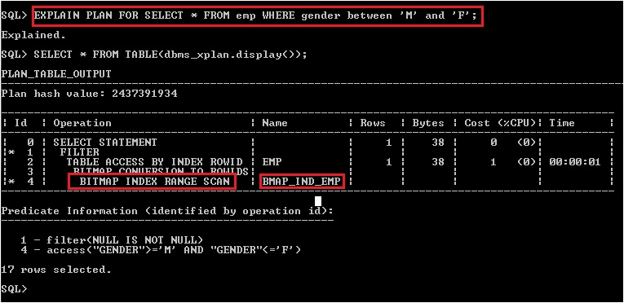

Join methods: The join method describes how data from two data producing operators will be joined together. You can identify the join methods used in a SQL statement by looking in the operations column in the explain plan. Oracle offers several join methods.

- Hash Join
- Nested Loop Join
- Sort Merge Join

Hash Join: Hash joins are used for joining large data sets. The optimizer uses the smaller of the two tables or data sources to build a hash table, based on the join key, in memory. It then scans the larger table, and performs the same hashing algorithm on the join columns. It then probes the previously built hash table for each value and if they match, it returns a row.

- Useful when large amounts of data to be join.
- Useful when table are join using equijoin.
- Hash join always perform in user memory not on server. Best when smallest table data can fit into memory.
- The optimizer uses the smaller of the two tables or data sources to build a hash table based on join key.
- Then scans the larger table, and performs the same hashing algorithm on the join columns. It then probes the previously built hash table for each value and if they match, it returns a row.
- Hints: USE_HASH(table1 table2)

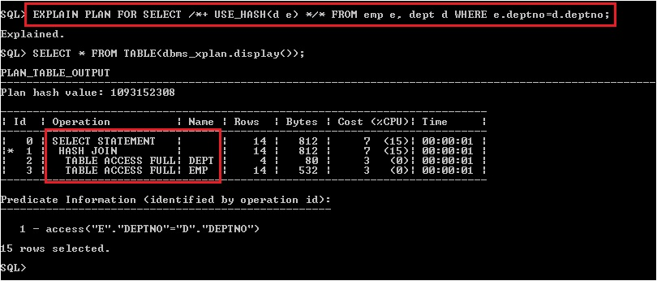
In above example, I have used hints to influence the optimizer to use hash join. Optimizer will choose hash join only when join need to perform on large subsets and will pick smaller subset to build hash table and then scan the larger subsets and perform hashing algorithm on join column, then return the matching rows.

Nested Loop Join: Nested loop joins are useful when small subsets of data are being joined and if there is an efficient way of accessing the second table (for example an index look up). For every row in the first table (the outer table), Oracle accesses all the rows in the second table (the inner table).

- Useful when join small subset of data.
- Optimizer determines the driving table (Outer table), which is independent of another table (Inner table).
- For every row in outer table, it accesses all the rows in the inner table and returns joining rows.
- Hints: USE_NL(Outer_Table_name Inner_Table_name)

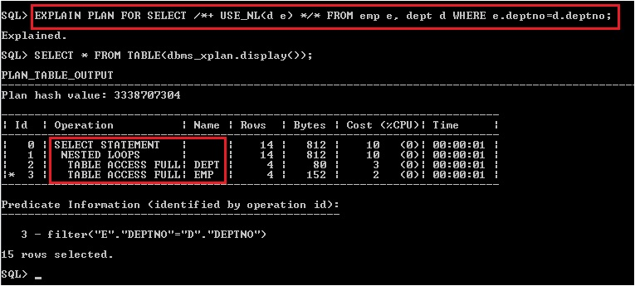
In above example, I have used hints to influence the optimizer to use nested join. Optimizer will choose nested join only when join need to perform on small subsets and will pick driving table which is independent of others table then for every row in outer table it will access the rows in the inner table and return joining rows.

Sort Merge Join: Sort merge joins are useful when the join condition between two tables is an inequality condition such as, <, <=, >, or >=. Sort merge joins can perform better than nested loop joins for large data sets.

The join consists of two steps:

Sort join operation: Both the inputs are sorted on the join key.
Merge join operation: The sorted lists are merged together.

A sort merge join is more likely to be chosen if there is an index on one of the tables that will eliminate one of the sorts.

- Useful for small subset of data.
- Sort merge join perform better than nested loop join when one or more row source are in sorted order.
- Useful when the join condition is an inequality condition.
- Hints: USE_MERGE(table1 table2)

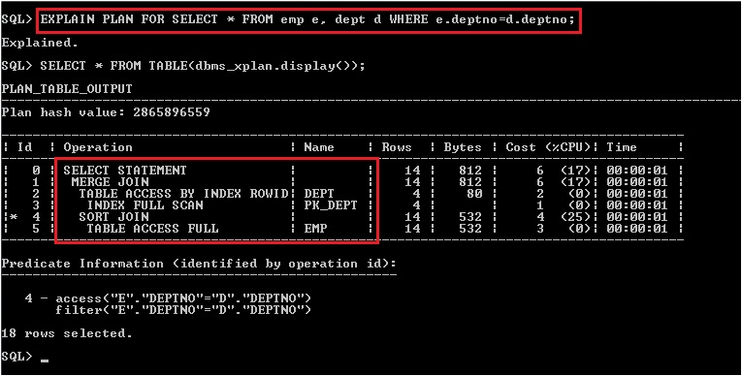

Other ways to generate execution plan: There are other ways are also available apart from using explain plan command by which we can generate/see the explain plan.

- AUTOTRACE
- DISPLAY_CURSOR() function.
- TKPROF

AUTOTRACE: This command will help to get the generated explain plan automatically from plan table after statement execution. We can flip this command on/off, by default it is off. We can turn this command ON and then execute the statement and see the generated explain plan.

Syntax: SET AUTOTRACE ON/OFF

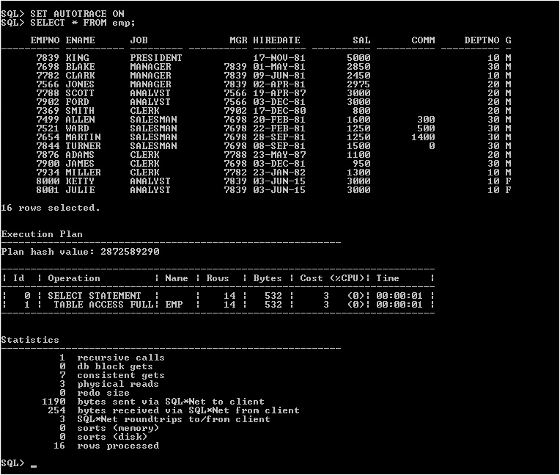
In above example, we have first ON the AUTOTRACE and then executed the statement and explain plan fetched automatically from plan table.
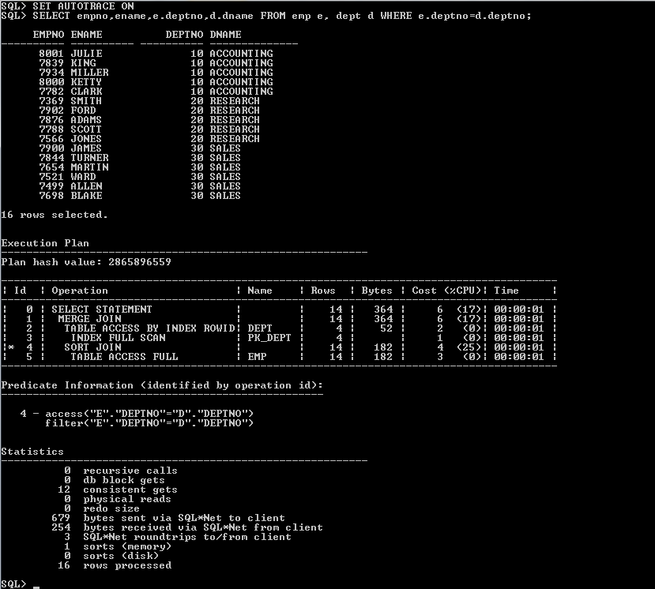

NOTE: We can trun off autotrace by using below command.
SET AUTOTRACE OFF
DISPLAY_CURSOR: It can display the execution plans for one or several cursors in the shared SQL area, depending on a filter criteria. It can display the plan for the last executed statement, the current (if session is active) or last executed statement (if session is inactive) of a specific session, or all cursors matching an arbitrary criteria defined via SQL. In addition to the explain plan, various plan statistics (e.g. io, memory and timing) can be reported (based on the v$sql_plan_statistics_all views).

Specific cursors are identified by SQL_ID and optionally a SQL_CHILD_NUMBER.
The DEFAULT without any parameters shows the last executed statement of the session.

NOTE: To use the DISPLAY_CURSOR functionality, the calling user must have SELECT privilege on V$SQL_PLAN_STATISTICS_ALL, V$SQL, and V$SQL_PLAN. By default, only the select_catalog role has the SELECT privilege on these views.
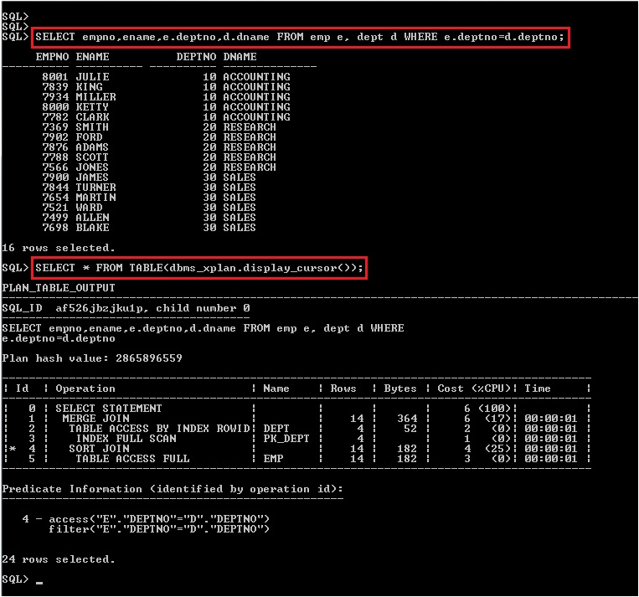
In above example, we have first executed the statement then used display_cursor() function to get the explain plan for last executed statement of current session.
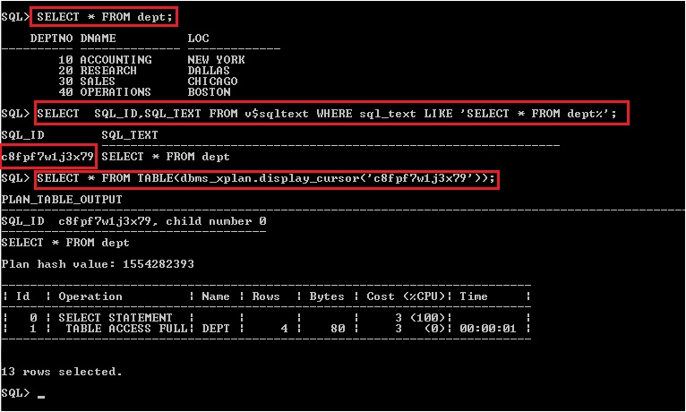
In above example, we have first executed the statement then get the SQL_ID of the statement from v$sqltext view and pass that SQL_ID in display_cursor() function to get the explain plan for that particular SQL_ID. With this we can get explain plan of all executed statements from all sessions as long as they are available in shared memory.

Object Statistics

From oracle 10g onwards, oracle using cost based optimizer as default optimizer. Which will generate multiple execution plan (max 20) for each statement and drive the cost of each plan, then pick the plan whose cost is less compare to others plan. The most important key to success with the CBO is to carefully define and manage your statistics. In order for the CBO to make an intelligent decision about the best execution plan for your SQL, it must have information about the table and indexes that participate in the query. When the CBO knows the size of the tables and the distribution, cardinality, and selectivity of column values, the CBO can make an informed decision and almost always generates the best execution plan.

There are multiple ways are available to gather the statistics in Oracle.
- Using DBMS_STATS Package.(Oracle suggested approach)
- Using ANALYZE Command. (Legacy)
- DBMS_UTILITY Package. (Legacy)
- Dynamic Sampling. (Hints)

DBMS_STATS: The DBMS_STATS package was introduced in Oracle 8i and is Oracle's preferred method of gathering statistics. Oracle list a number of benefits to using it including parallel execution, long term storage of statistics and transfer of statistics between servers. Using this package we can collect statistics for Table, Index, Cluster, Schema, and Database.

NOTE: The statistics can reside in two different locations:
- In the data dictionary.
- In a table created by user in the user schema.

Only statistics stored in the dictionary itself will have an impact on the cost-based optimizer.
Procedures in dbms_stats package are having one parameter “stattab”. If you want to store and manipulate statistics in user defined statistic table then pass the table name to this parameter. If this parameter value is not passed or passed as NULL then oracle will apply the changes in data dictionary.

Procedures to gather statistics:

dbms_stats.gather_table_stats (owner, table name);
dbms_stats.gather_index_stats (owner, index name);
dbms_stats.gather_schema_stats (schema_name);
dbms_stats.gather_database_stats (database_name);

Procedures to delete statistics:

dbms_stats.delete_table_stats (owner, table name);
dbms_stats.delete_index_stats (owner, index name);
dbms_stats.delete_schema_stats (schema_name);
dbms_stats.delete_database_stats (database_name);

Procedure to create/drop user defined statistics table:

dbms_stats.create_stat_table (owner, stattab, tblspace, global_temporary);

stattab => Name of user defined statistic table.
tblspace => Name of table space. Default value is NULL
global_temporary => Global temporary table True/False. Default value is False.

dbms_stats.drop_stat_table (owner, stattab);

Apart from these there are several procedures available in dbms_stats package to perform different task related to statistics like archival of old statistics, restore old statistics, import & export statistics, Lock and unlock the objects from statistic update etc.

The current statistics information’s are available in the data dictionary views for the specific objects. Some of the view name listed below.

Table related views:

dba_tables, all_tables, user_tables
dba_tab_statistics, all_tab_statistics, user_tab_statistics

Index related views:

dba_indexes, all_indexes, user_indexes
dba_ind_statistics, all_ind_statistics, user_ind_statistics

Let start with statistics:

Step 1: Creating a new table.

Step2: Checking available statistics of newly created table.
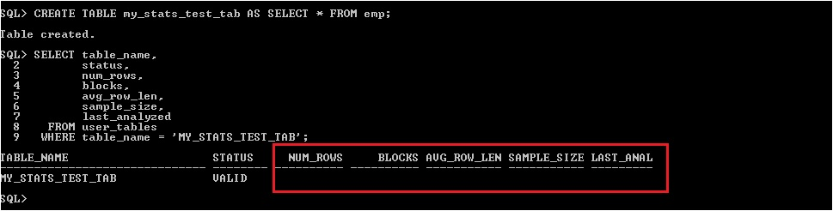
Table statistics are not available.

Step 3: Generating explain for statement which is referring newly created table.
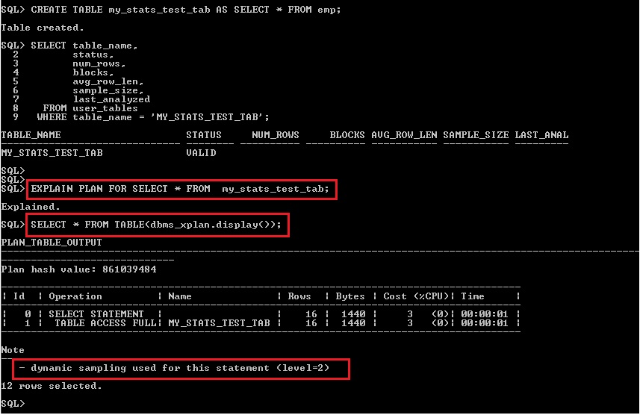
In Note section of plan we can see optimizer has created the dynamic sample and used that to generate the plan. Optimizer will generate dynamic sample only when statistics of used object is not available in oracle dictionary and dynamic sampling level is not defined as 0 for parameter OPTIMIZER_DYNAMIC_SAMPLING.

Step4: Gathering/collecting stats of newly created table using dbms_stats package.
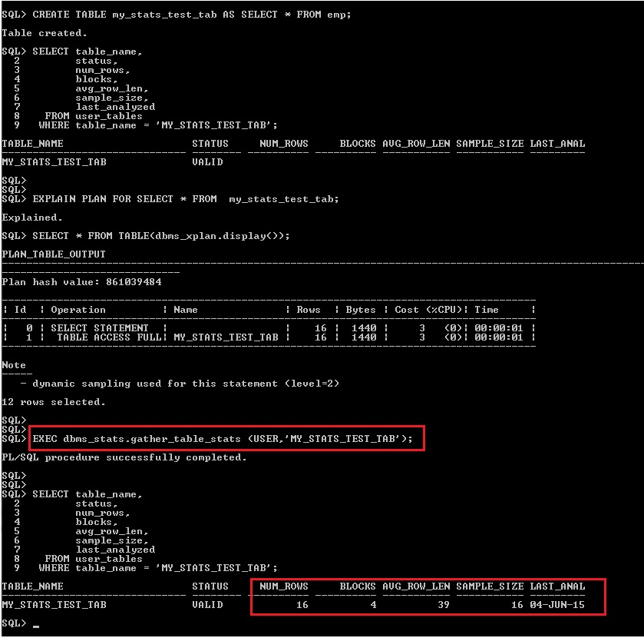
After execution of procedure statistics of newly created table got updated.

Step 6: Once again generating explain for statement which is referring newly created table.
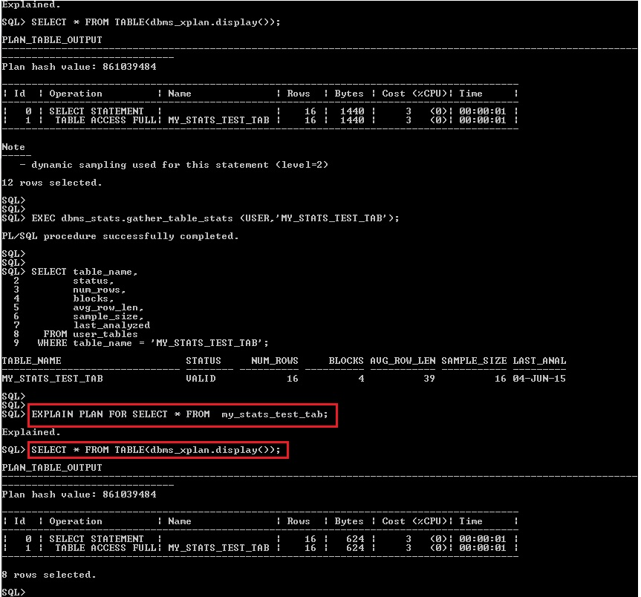
We can see optimizer hasn’t created dynamic sample since statistics of object is available in dictionary.
We can delete the statistics of table using delete_table_stats procedure.
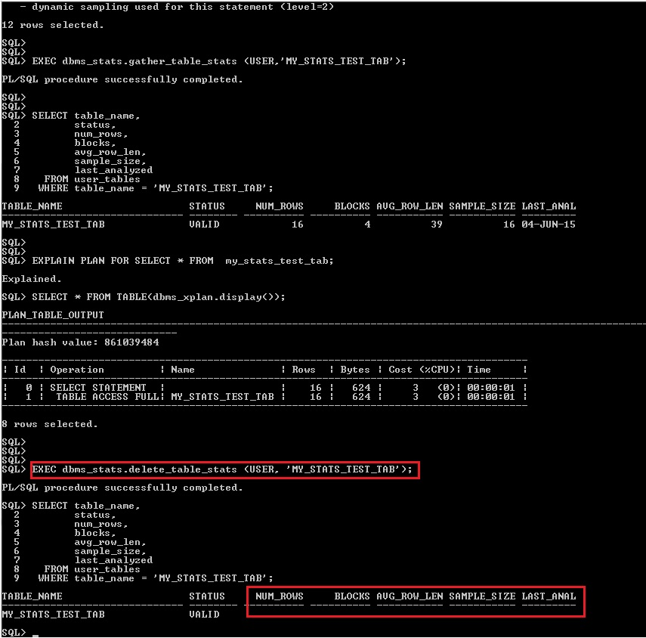

NOTE: In similar way we can gather and remove the statistics of index, cluster, complete objects of a schema and database by using respected procedure available in dbms_stats package.
Create your own statistics table:

Step 1: Creating user defined statistics table.
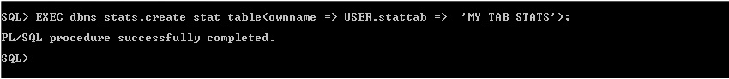

Step 2: Checking newly created stats table. Table is not having any data.
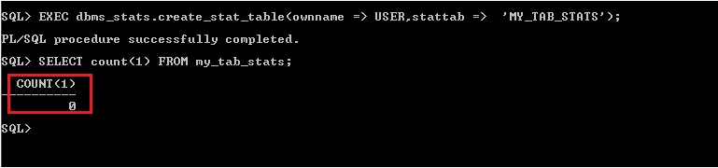

Step 3: Gathering stats in newly created stats table.
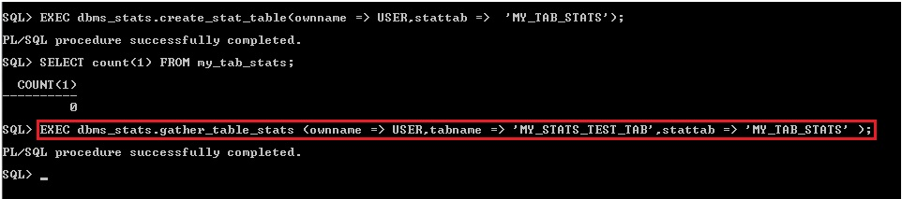

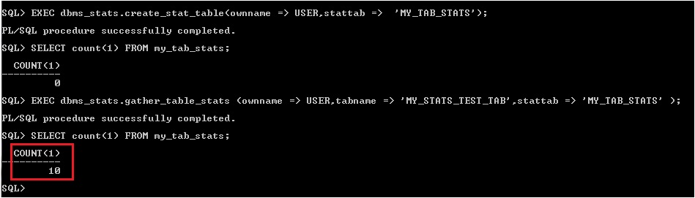
After execution of procedure stats got updated into newly created stats table. Creating stats in user defined stats table will not affect the dictionary stats and optimizer will not consider the user defined stats table to generate the plan.

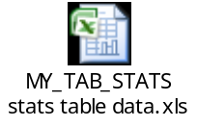Stats table data
We can delete the statistics from user defined stats table using delete_table_stats procedure as shown below.
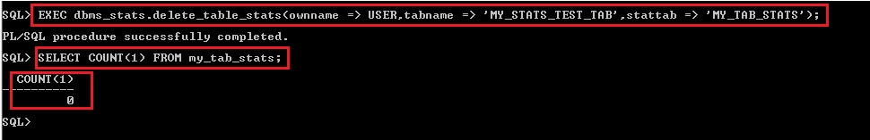

We can drop user defined stats table using drop_stats_table procedure.
